THE ART OF DISTILLATION AND EXTRACTION

A One-Off International Masterclass at The Origins Centre, Balingup, Western Australia.

April 27th & 28th 2019

An intensive two-day workshop with craft distiller of aromatics, Jill Mulvaney from Alembics NZ. Learn about the ancient and enduring art of distillation using handmade Portuguese copper stills and modern stainless steel styles. Respectfully harness the unique, native plant power of native Australian aromatics using a wide variety of plant extraction techniques.

About The Origins Centre

The Origins Centre is a registered charitable, not-for-profit organization in Western Australia.
Operating as respite, retreat and community activity center and located just outside the town of Balingup — a 3-hour drive southwest of Perth — The Origins Centre, is a beautiful, mindful venue with extensive gardens, and simple, communal accommodation.

For more information about The Origins Centre and Balingup please click here http://www.originscentre.org/.

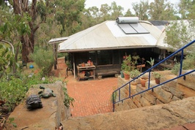

Workshop Overview

Day One

Saturday 27th April
1030am to 330pm

THE ART OF DISTILLATION: USING WATER AS A SOLVENT

Botanical and herbal infusions
- How to select and prepare your botanicals
- How to make use of infusions

Hydrosol
- Hydro-distill a native Australian botanical using a Traditional Alembic copper still
- Learn about harvesting, applications, PH levels, filtering, closed sterile distillations and storage

Break for a Botanical Spritz and group lunch

Essential Oil
- Steam distill a native Australian botanical using an Alembics copper Column still
- Learn about harvesting, plant preparation, separation, storage, and applications
- Distill a native Australian botanical using a stainless steel Explorer still
- Compare and contrast copper and stainless steel methods, processes and outcomes

Decoctions, sherbets, and cordials
- Prepare a botanical bitters using water as a solvent
- Invent your own botanical, ethanol free cocktail.

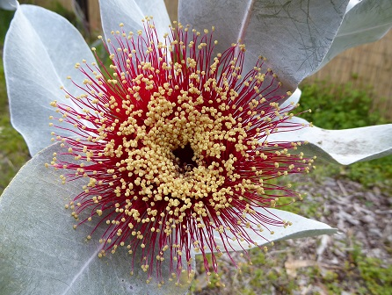

Day Two

Sunday 28th April 2019
1030am to 330pm

THE ART OF DISTILLATION: USING ALCOHOL AS A SOLVENT

Eau de vie
- Transform a fruit wine or ferment into a white spirit

Tinctures & Distilled Perfumes
- Learn how to prepare tinctures and what to do with them
- Learn how to make distilled perfumes using native Australian essential oils

Maceration & Filtering
- Experiment by steeping fruits and botanicals in a neutral spirit
- Filter, store and apply

Break for a group lunch and a botanical spritz

Vapour Infusion
- Blend your own botanical gin using traditional and native Australian aromatics

Finish with an artisan gin and tonic or zero abv botanical cocktail.

Notes covering all processes demonstrated on the day will be provided along with a list of resources, including books, ongoing training, and online links. Sample bottles of products can also be taken home.

Accommodation

Need help with Accommodation? The Origins Centre offers simple, communal style accommodation for those attending courses and retreats. Please see the following link for details, and to make booking enquiries. http://www.originscentre.org/staying-at-origins.html.

Alternatively, other private accommodation can be arranged. Please refer to the following links for details. https://www.airbnb.com.au/s/Balingup--Australia
https://balinguptourism.com.au/accommodation/.

Getting to the Origins Centre

The Origins Centre is approximately 3 hours drive from Perth, Western Australia. Please see the map below for further details.

Cost

1 day: $225
2 days: $425

Please contact us at info@alembics.co.nz with any questions.

