Indian Head Massage – Course
1-2 June 2019
Venue: Origins Centre BALINGUP

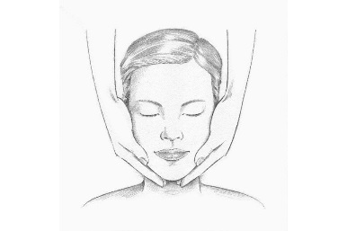

A practical, hands-on introductory course in the basics
of Indian Head Massage. Following a brief discussion of the background of the technique, students will be guided through some of the various shoulder, neck, scalp and face massage techniques, practicing on other students within the class. The massage is done from a seated position, and there is no need to remove clothing. At the end of the course students will be able to give a basic head massage, and will be eligible to receive a certificate. The course will culminate in each student giving and receiving a 30 minute Indian Head Massage.

Your practitioner Trainer is Miranda Divine (0418948017) who has taught the method through Adult Education in TAFE and the Midland Women’s Health Care Place over the past 10 years. Miranda has a Cert IV in Training and Assessment and has more than 20 years experience in massage and other natural therapies.

Times: 9.45am Saturday Registration (in the Rotundra),
10am - 12 noon Sat and Sunday
2pm - 4pm Sat and Sunday
8hrs of instruction (may vary on group size)

Residential or Day visitors welcome
A light morning tea is provided
Cost : $135, Early bird bookings and Concession $120
$50 deposit required to secure your place.

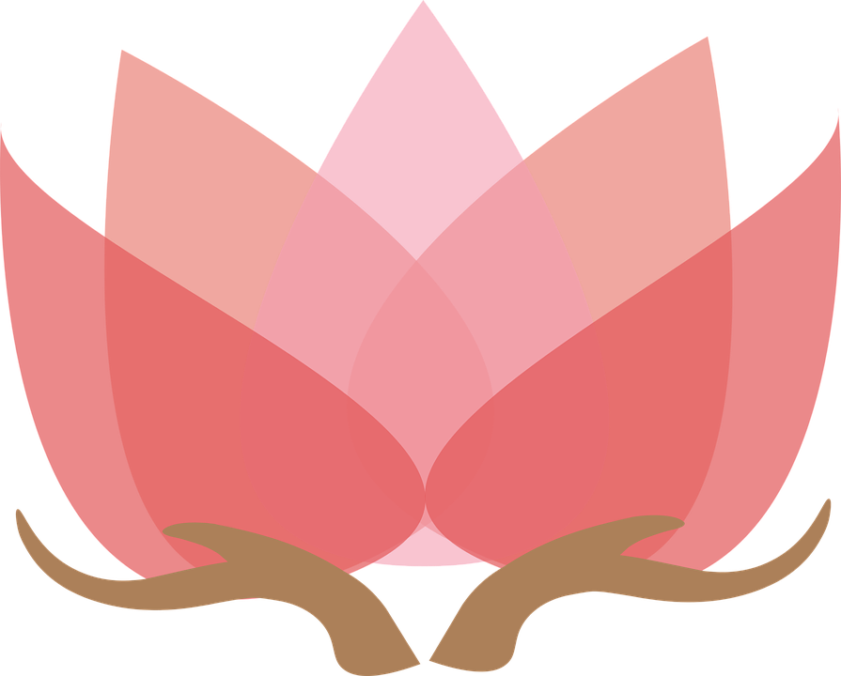

Bookings options via EVENTRBRITE (to be set up) or directly to Miranda Divine.

Residential bookings will need to be made through the Origins Centre. Please check their website for protocol and respect. A contribution (Dana, or donation, is appreciated for your accommodation)

BYO
- Two hand towels
- Optional massage oil, or moisturising cream
- Healthy snacks to share
- Correct cash for payment as we may not have change.

Enquiries and bookings welcome.
Miranda Divine 0418948017
mirandadivine@optusnet.com.au

